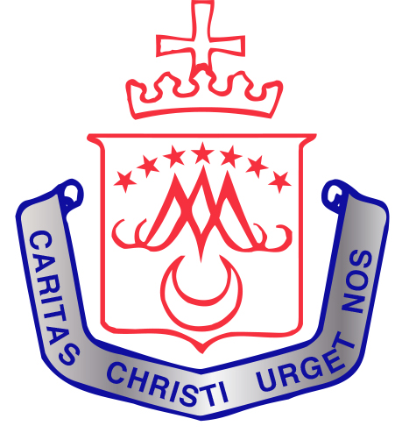

St. Vincent’s Convent Primary School
ANNUAL ADMISSION NOTICE
in respect of admissions to the 2023/2024 school year

Admission Policy and Application Form
A copy of the school’s Admission Policy and the Application Form for Admission for the 2023/2024 school year is available as follows: –
To download at: www.stvincentsns.ie
On request: By emailing secretary@stvincentsns.ie or by phoning 0214306909

PART 1 - Admissions to the 2023/2024 school year

Application and Decision Dates for admission to 2023/2023 school year
The following are the dates applicable for admission to Junior Infants

The school will commence accepting applications for admission on | Oct. 3rd 2022
The school shall cease accepting applications for admission on | Oct. 28th 2022
The date by which applicants will be notified of the decision on their application is | November 11th 2022
The period within which applicants must confirm acceptance of an offer of admission is | By November 30thor Within 1 week of receipt of offer

Note: St. Vincent’s Convent Primary School will happily consider and issue decisions on late applications in accordance with the school’s admission policy.

Special Class Application and Decision Dates for admission to 2022/2023 school year
The following are the dates applicable for admission to the school’s Special Class which caters for children with [insert details of category/categories of SEN catered for in the class] -
The school will commence accepting applications for admission to the special class on | Oct. 3rd 2022
The school shall cease accepting applications for admission to the special class on | When the class is full
The date by which applicants will be notified of the decision on their application for admission to the special class is | Feb. 28th 2023
The period within which applicants must confirm acceptance of an offer of admission is | 28/02/23-10/03/23
*Failure to accept an offer within the prescribed period above may result in the offer being withdrawn

Number of places being made available in 2022/2023

The number of places being made available in junior infants is | 40
The number of residential places is (boarding schools only) | n/a
The number of non-residential places is (boarding schools only) | n/a
The number of places being made available in the Early Intervention Class catering for children with ASD | 2
The number of places being made available in the Junior Infant ASD Class | 0

