St. Vincent’s Convent Primary School
St. Mary’s Road,
Cork
Phone: 021-4306909
Email: principal@stvincentsns.ie
secretary@stvincentsns.ie

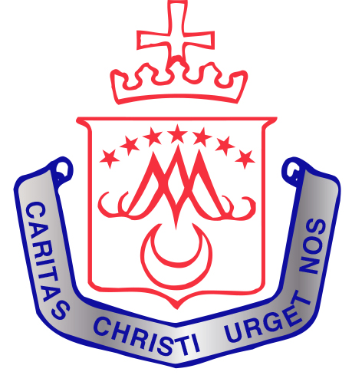

ENROLMENT FORM 2022/2023

Class
Junior Infants 3rd class Early Intervention ASD class
Senior Infants 4th class
1st class 5th class
2nd class 6th class

Pupil’s forename: ______________________ Pupil’s Surname: __________________
Gender: Male Female
Pupil’s Date of birth: __________________________________________________________
Pupil’s PPSN Number: ___________________________________________________________
Address: _____________________________________________________________________
Eircode: _______________________________________________________________________
Parish: _______________________________________________________________________
Nationality: (as on birth certificate) ___________________________________________________
Religion: __________________________________________________________________________
First language spoken at home: ________________________________________________________

Mother’s Name: _________________________________ Mobile No. _____________________________
Father’s Name: __________________________________ Mobile No. ____________________________
Mobile Number for text messages from school: ____________________________________________
Emergency Numbers: (childminder/grandparents/relatives) ____________________________________
______________________________________________________________________________________
Name of Previous pre-school or school : ______________________________________
Any difficulty with: hearing vision speech other
Referral to other agencies: Has your child been referred to Speech & Language Therapy, Tusla, Psychologist, or a Specialist? _________________________________________________________________
______________________________________________________________________________________
______________________________________________________________________________________
Dear Parent/Guardian,
Thank you for your application to have your child admitted to St. Vincent’s Convent Primary School for September 2022. Please return a copy of your child’s birth certificate and a signed copy of the Code of behaviour with this form.
We look forward to meeting you and your child.

_Niamh O’ Sullivan_
Niamh O’ Sullivan, Principal

